3 Types of Muscle Tissue:
1.
2.
3.
O2 Mitochondria Glucose/Monosaccharide Ca+ Protein
Acetylcholine Action Potentials Na+ K+ Motor neuron
Twitch fibers Tendons Fascia ATP Muscle fibers
Myofilaments Nodes of Ranvier Synaptic knobs Receptors
Synaptic cleft Motor end plate Neuromuscular junction Enzyme
CNS ANS Motivation to move Effectors

Structure of a Skeletal Muscle
Connective Tissues
- Fascia -
- Tendons –
- Aponeuroses -

Anatomy of a Skeletal Muscle
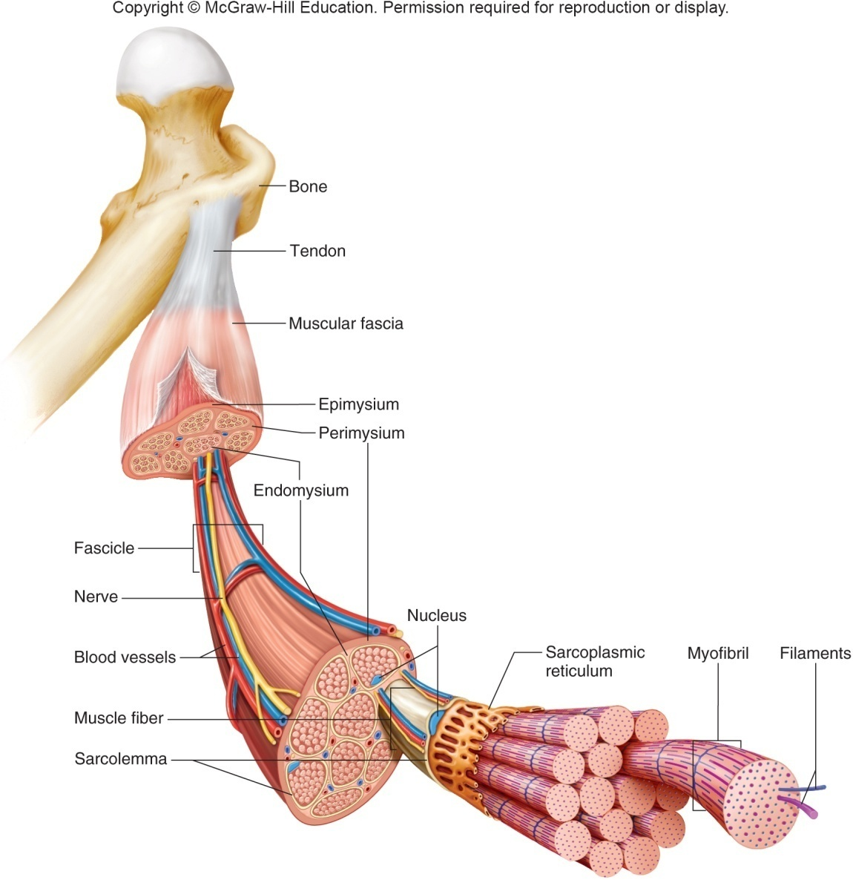

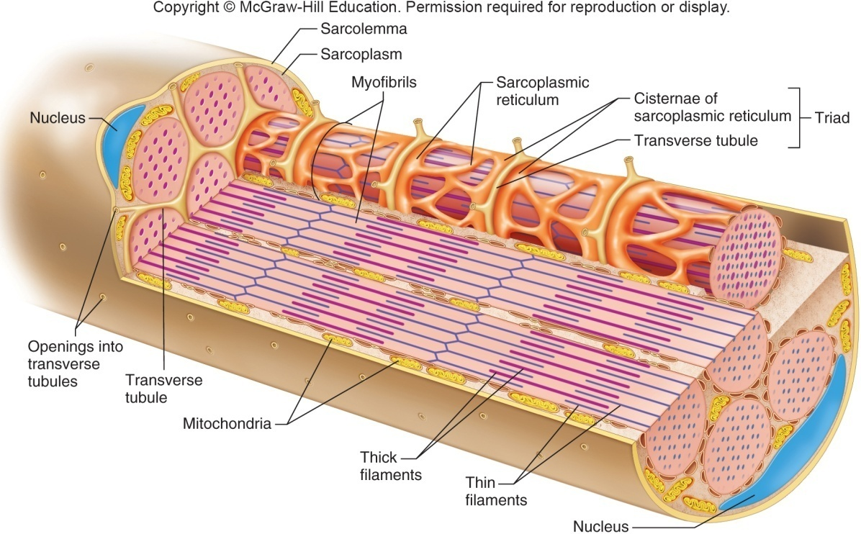
Skeletal muscle fiber = muscle cell
- Multinucleated

- Sarcolemma

- Sarcoplasm

- Myofibrils consisting of:
-thin actin filaments
-thick myosin filaments

- Sarcomeres

- Sarcoplasmic reticulum (SR)

- Transverse (‘T’) tubule

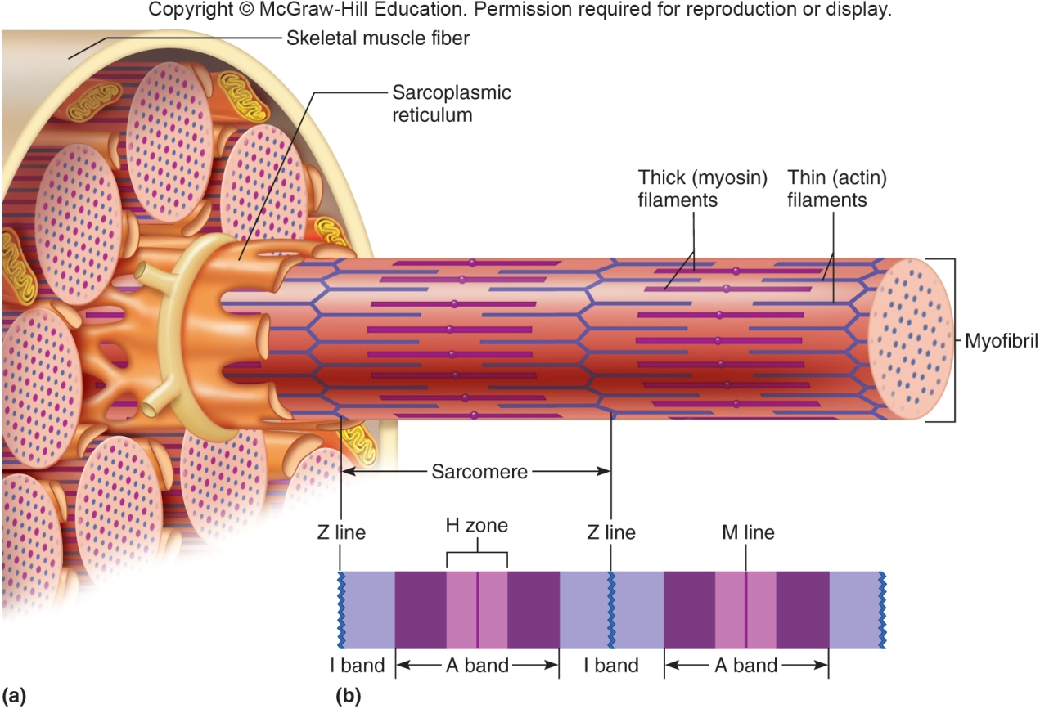
- I Band: Light band, composed of thin actin filaments
- A Band: Dark band, composed of thick myosin filaments overlapping with thin actin filaments
H Zone: Center of A band; composed of thick myosin filaments
- Z Line: Anchors filaments in place; sarcomere boundary; center of I band
- M Line: Anchors thick filaments; center of A band

Contractile Proteins:
- ________________________
- ________________________
- ________________________
- ________________________

Neurology:
Neuron –

Local potential changes –

Action Potential –

Neurotransmitter –

Neuromuscular Junction
  - Motor neuron -
  - Motor end plate -
  - Synaptic cleft -
  - Synaptic vesicles -
  - Neurotransmitters -

Stimulus for Contraction

Steps of Muscle Contraction

Muscle Relaxation
Acetylcholinesterase –

Calcium pump –

Troponin-tropomyosin complex –

Muscular Responses
Threshold Stimulus –

Twitch –
- Fast twitch
- Slow twitch

Hypertrophy vs. Atrophy –

Recruitment of Motor Units
Gross motor -

Fine motor -

Muscle Diseases:

Muscle contraction terminology
- Origin
- Insertion
- Prime mover
- Agonist
- Antagonist
- Synergist
- Isotonic
  - Concentric
  - Eccentric
- Isometric

Length-Tension relationship

Energy Sources
- ATP reserves
- Creatine phosphate
- Cellular respiration
  - Anaerobic phase
  - Aerobic phase

Skeletal Muscle Actions
Articulation/Joints -
Synovial Joints
- Ball & Socket –
- Plane –
- Hinge –
- Pivot –
- Saddle –
- Condylar –

Muscle Fatigue & Cramping

