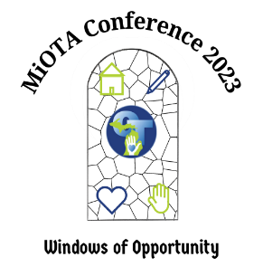

MICHIGAN OCCUPATIONAL THERAPY ASSOCIATION
ANNUAL FALL CONFERENCE
OCTOBER 5 – 7, 2023
MACKINAW ISLAND

SCHEDULE OF EVENTS
Thursday, October 5:
Registration: 12 PM – 5:30 PM
Exhibitor set-up: 12:00 PM – 4:30 PM
Sessions: 1:00 PM - 3:15 PM
SIS meeting / Sessions: 3:30 PM – 4:30 PM
Unopposed exhibits: 4:30 PM – 5:30 PM
Welcome reception: 5:30 PM - 6:30 PM
Board meeting (invite only: Pontiac Room): 7 PM – 9 PM
Alumni events (locations to be determined): 9 PM – 11 PM
Friday, October 6
Registration: 7 AM – 5 PM
Breakfast 7:30 AM
Keynote address: 8:30 AM – 10 AM
Breakout sessions: 10 AM - 3:30 PM
Unopposed exhibit time / lunch (on your own): 12:30 PM – 1:15 PM
SIS meeting / Sessions: 3:45 PM – 4:45 PM
Awards ceremony / By-laws updates: 5 – 6:30 PM
PAC event (cancelled)
Saturday, October 7
Registration: 7 AM – 1 PM
Breakfast 7:30 AM
Business meeting: 8:30 AM - 10:00 AM
Unopposed exhibit time: 10 AM – 10:30 AM
Breakout sessions: 10:30 AM - 12:45 PM
Unopposed exhibit time / lunch (on your own): 12:45 PM – 1:30 PM
Exhibitors close at 1:30 PM
Licensure topic: Pain 1:30 PM – 2:30 PM
Licensure topic: DEI 2:45 PM – 3:45 PM
Conference concludes: 3:45 PM

Grand Hotel Information
To make reservations please visit the MiOTA website (not the Grand Hotel site) to make your reservation using the link.
Room block ends Sept 5th or sooner based upon availability.
Reservation includes full breakfast and a formal dinner.
 | Single | Double (2+ in a room) | Student (3+ in a room)
Standard – Interior View | $315 / night | $195 / person / night | $145 / person / night
Deluxe – Lake View | $385 / night | $230 / person / night | -
Students to contact conference@miota.org to obtain student rate.
There are additional fees the hotel will apply which includes luggage, resort, taxes, and gratuity.
The hotel provides baggage/passenger transportation from dock to hotel via horse and carriage.
Hotel Meals
Breakfast 7:30-10 (included for hotel guests)
Lunch (on your own)
Dinner 6:30-8:45 (included for hotel guests)
Hotel Events
Pre-dinner cocktails in the parlor 5:30-6:30
Music in the parlor 8-9:30
Dancing in Terrace Room 9:30-11
Hotel Dress Code
Specific attire is requested by the hotel be sure to view their policies by visiting their website or reading the email that you receive that confirms your reservation.
Hotel
Check in: 4 pm; Check out: 11 am
Luggage
Your reservation includes tips and transportation dockside for you and your luggage (via horse and carriage) to / from the hotel.
For arrival: If guests arrive prior to check-in, pre-register with the Front Desk upon arrival and turn in luggage tags. When their luggage arrives and rooms become ready, the bell staff can deliver the luggage to the guestroom without delay. The Front Desk will send the guests a text to let them know their room is ready.
For departure, the hotel will do group luggage sweep, by 8AM at the latest on the day of departure. Guest services will deliver a departure letter and luggage tags the night prior to departure. The guests should have their luggage packed and placed outside their rooms prior to 8 AM. Guest Services sweeps the floors and picks up luggage to get it on the next available ferry. When guests depart around 11AM, their luggage should be waiting for them on the mainland, and they pick up their luggage at the dock and head on their way home. Luggage sweeps after 8AM, may lead to delays in delivery to the mainland.

Shepler’s Ferry
Discounted tickets are available at https://www.sheplersferry.com/
Use the code: MiOTA (case sensitive).
Rates are $23/adult and $14/child (ages 5-12) roundtrip.
Mackinaw City: All options are self-parking.
- Day Parking: FREE (off-site)
- Standard Parking: $15.00/night (off-site)
- Premium Parking: $35.00/night on-site at the dock (gate ticket required for entry/exit)
(Shepler’s will provide continuous shuttle service to and from the off-site lots)
St. Ignace: All options are self-parking.
- Day Parking: FREE (on-site)
- Standard Parking: $15.00/night off-site (gate ticket required for entry/exit)
- Premium Parking: $20.00/night on-site at the dock (gate ticket required for entry/exit)
(Shepler’s will provide continuous shuttle service to and from the off-site lots)

MiOTA CONFERENCE FEES
Conference  Registration  Fees | GRAND HOTEL GUEST  AND  MiOTA MEMBER  (Includes breakfast and dinner) |  | MEMBER OF MiOTA  NOT STAYING AT GRAND HOTEL  (Meals not included) |  | GRAND HOTEL GUEST  BUT NOT A  MiOTA MEMBER  (Includes breakfast and dinner) |  | NON-MEMBER OF MiOTA  NOT STAYING AT GRAND HOTEL  (Meals not included)
 | Early  Now – Sept 5 | Late  Sept 6 – Oct 4 | Early  Now – Sept 5 | Late  Sept 6 – Oct 4 | Early  Now – Sept 5 | Late  Sept 6 – Oct 4 | Early  Now – Sept 5 | Late  Sept 6 – Oct 4
One-Day  Thursday, Friday, or Saturday | $150 | $175 | $200 | $225 | $250 | $275 | $300 | $325
Full Conference  2 or 3 days | $175 | $200 | $225 | $250 | $275 | $300 | $325 | $350
Welcome Reception  Thursday Evening | included | included | $10 | $10 | included | included | $10 | $10
Award Ceremony  Friday  Evening | $5 | $5 | $10 | $10 | $10 | $10 | $10 | $10
Alumni Event  Thursday Evening | included | included | included | included | included | included | included | included
Guest Rate Per Event or Session | $25 | $25 | $25 | $25 | $25 | $25 | $25 | $25
DISCOUNT  Speaker,  OTA,  Retired | $25 | $25 | $25 | $25 | None | None | None | None
DISCOUNT  Student, Student Speaker | $50 | $50 | $50 | $50 | None | None | None | None

SESSION DESCRIPTIONS

THURSDAY, OCTOBER 5, 2023

THURSDAY, OCTOBER 5, 2023
1-3 PM
Room: Headquarters
Reid, Hayes
Ergonomics at School, Work and Home: from Basic to Complex to Creative
The term “ergonomic” is thrown around a lot, but what does it really mean? And what should OTs know about ergonomics to better serve their diverse populations? This presentation will begin with the basic rules of ergonomics as it is applied with office workers. We will then show you when and how to apply those rules with working in different environments, such as manufacturing, materials handling, and education, or when addressing workers with a wide range of disabilities, including sensory, intellectual, and physical. Participants will gain an appreciation of the creativity needed to address improving ergonomics in challenging situations.
Objectives
1. Participants will know and be able to apply basic ergonomics principles to normative populations in an office environment.
2. Participants will recognize variations from standard ergonomics in terms of both environmental factors and personal function of the worker.
3. Participant will be aware of resources to address ergonomic issues in outlier situations.

Below session was cancelled by speaker on 8-17-23
THURSDAY, OCTOBER 5, 2023
1-3 PM
Room: Brighton
Staton
The importance of educating parents on sensory integration to decrease anxiety in young children.
Children with sensory challenges often experience increased anxiety surrounding various experiences such as: trying new foods, changes in routine, completing certain essential hygiene and grooming tasks, and going to novel places. These situations can lead to feeling overstimulated and overwhelmed, which results in meltdowns. This affects the entire family unit, and can leave parents feeling helpless, discouraged, and stressed if they do not feel confident in their ability to effectively respond to their child’s needs. It is our duty as occupational therapists to support the mental wellness of the entire family by empowering parents with information and strategies needed to promote and maintain their child’s regulation, and thereby decrease anxiety. This session aims to provide practitioners with knowledge, methods, and structure for increasing parental involvement and efficacy when responding to their child’s nuanced sensory needs.
Objectives
1. Understand how active parent involvement impacts child’s development and regulation
2. Apply parent education framework for improved therapy outcomes.
3. Assemble specific strategies to increase parent involvement and decrease child anxiety

THURSDAY, OCTOBER 5, 2023
1-2 PM
Room: Grand Pavilion
Johnson, C
It is not just about removing the throw rug! - Home Assessment
This session will support advancement of current home and environmental procedures to exude the distinct value of occupational therapy. Lack of fit between the home and the person can lead to injury and rehospitalization. This course will discuss the current state of home assessments, discuss the importance of an occupational therapy led assessment, and review a variety of assessment tools that can be used to gather clinical information and support interventions that are occupation-based.
Objectives
1. Participants will be able to identify at least two factors that lead to rehospitalizations.
2. Participants will be able to identify at least two benefits of an occupational therapy led home assessment.
3. Participants will be able to identify at least two home assessment tools that could be incorporated into their practice.

THURSDAY, OCTOBER 5, 2023
1-2 PM
Room: Ford
Johnson, S; Justice
Functional Implications of Parsonage Turner Syndrome
Parsonage Turner is considered a rare disorder which involves an abrupt onset of pain followed by sudden weakness and loss of active range of motion (Smith & Bevelaqua 2014). This condition impacts a variety of nerve distributions which make a diagnosis and treatment difficult. This presentation will provide information regarding the etiology of Parsonage Turner, diagnostic tests used to confirm the condition, and the importance of occupational therapy among an interdisciplinary team and the positive impact upon the patient outcomes. Evidence based treatment interventions and case studies will be presented.
Objectives
1. Define Parsonage Turner Syndrome
2. Understand implications of Parsonage Turner on functional performance
3. Identify interventions to increase functional performance in patients diagnosed with Parsonage Turner Syndrome

THURSDAY, OCTOBER 5, 2023
1-2 PM
Room: Straits
Fliearman
There's an app for that?! AT for Reading Challenges
As occupational therapists we work with individuals with barriers. Once common barrier encountered from elementary school through adult employment is poor or limited reading. At Michigan’s Vocational Rehabilitation Training center many of our students have learning disabilities in reading and writing. It is critical to stay current with technology to provide reading and writing accommodations individuals can use independently in their training and eventually in employment. We will review current apps, built-in reading accommodations within Edge/Windows/iOS/Android phones with text-to-speech and speech-to-text technology to aid in making written material accessible to those with reading disabilities. My hope is to increase your awareness and understanding of current technology accommodations available and the value of these technology accommodations within Occupational Therapy. I will share case studies on students who have benefitted from this accommodation and statistics showing the inequity of testing and employment outcomes of those with reading challenges and those without. As occupational therapists we can know more and do more.
Objectives
1. Increase your knowledge and understanding of specific learning disabilities in reading and writing
2. Learn current technology within portable technology apps to accommodate reading challenges
3. Learn current technology within Windows programing to accommodate reading challenges

THURSDAY, OCTOBER 5, 2023
1-2 PM
Room: Kelly Brighton
Yatczak, Garvey
Mental Health and Occupational Therapy: Filling the Hole in our Holistic Practice
Since its beginnings, occupational therapy has promoted mental health through engagement in meaningful occupation. The current mental health crisis is a worldwide phenomenon affecting every aspect of society. The impact is significant; depression is one of the leading causes of disability, suicide is the fourth leading cause of death among 15–29-year-olds, people with severe mental health conditions die prematurely (World Health Organization, 2023). OT is poised to play a leading role in the integration of mental health and physical health services. In this presentation learn about principles and treatment techniques that you can use immediately in your practice such as pre-resilience (Schneider & Mcquirk, 2020), eudemonic well-being (Ryff, 2023), behavioral treatment of depression (Moustafa, 2022) and occupation-based interventions as a lifestyle medicine modality (Phillips, et al., 2020) to improve well-being and quality of life. It is a time for optimism, and it is time to reclaim our role in mental health.
Objectives
1. Participants will be able to describe occupational therapy’s historical and contemporary role in mental health.
2. Participants will be able to evaluate practice habits and opportunities to address mental health issues with clients across age groups, conditions, and practice settings.
3. Participants will be able to incorporate contemporary mental health treatment techniques and principles into everyday practice.

THURSDAY PM POSTER SESSIONS
(Attend 4 to receive 1 contact hour)

THURSDAY, OCTOBER 5, 2023
2:15-3:15 PM
Room: Theater
Fallon, Yost, Harper, Murphy
Development of a Toolkit for Newly Diagnosed Individuals with Scleroderma
Scleroderma is a rare disease that affects participation in numerous life roles. Symptoms range in severity and greatly impact quality of life. Scleroderma-related resources are limited, and when they are available, patients rarely use them (Milette et al., 2018). University of Michigan’s Scleroderma Program offers a peer mentor program, support groups, and the ability to participate in research for scleroderma. Yet, feedback from participants indicates a need for support and educational resources for newly diagnosed patients. Developing a community- engaged toolkit for newly diagnosed individuals with scleroderma will address an identified gap in clinical care and be a valuable addition to support patients' self-efficacy and self-management of this rare disease. This poster is currently in progress and will aim to discuss the creation and evaluation of a multifaceted toolkit for individuals newly diagnosed with scleroderma using community-engaged research methods.
Objectives
1. Describe the OT role when addressing the occupation of Health Management for individuals newly diagnosed with scleroderma
2. Discuss how community-engaged research methods were used in creation of the toolkit.
3.Identify outcome measures used to evaluate the impact of an educational toolkit for individuals with scleroderma

THURSDAY, OCTOBER 5, 2023
2:15-3:15 PM
Room: Theater
Woodworth
Interprofessional Education Book Club
The Interprofessional Education Book Club takes an in-depth look at healthcare from the perspective of a critically ill patient using the book: In Shock: My Journey from Death to Recovery and the Redemptive Power of Hope, by Rana Awdish. Research suggests the following about healthcare students & outcomes: 1) empathy decreases in undergraduate healthcare students; 2) clinical empathy improves patient outcomes; 3) book clubs may improve IPE learning & empathy. Occupational therapy is looked at as part of an interdisciplinary team reflecting on the patient's perspective of care in an effort to create an environment of increased empathy and client-centered care.
Objectives
1) development of empathy from the patient's perspective
2) increase interprofessional collaboration through healthcare education and training
3) create effective communication regarding labels, flawed models, seeing disease vs. seeing people, and resiliency

THURSDAY, OCTOBER 5, 2023
2:15-3:15 PM
Room: Theater
Hock; Bailey; Calzada; Dunleavy-Shotsberger; Hubert; Makowski; Nelson; Wilson; Zimmer
Survey of Hand Strength Instruments Used in Clinical Settings
Normative data on hand strength commonly used in clinical practice is from Mathiowetz et al. (1985). This survey examined which hand strength instruments are currently used in clinical practice, and which instruments would be selected for future purchases. This data could be used to inform future research on normative data of grip and pinch strength.
Objectives
1.Identify the most commonly used instruments to assess grip and pinch strength.
2. Identify which instruments clinicians would purchase to assess grip and pinch strength.
3, Learns which are the most common factors clinicians consider when selecting instruments to assess grip and pinch strength.

THURSDAY, OCTOBER 5, 2023
2:15-3:15 PM
Room: Theater
DiZazzo-Miller, East, Bevza, McKelvey
Caregiver Voices: Informing Practice for the Aging with Chronic Conditions
INTRODUCTION: The role of caregiving is widely stigmatized as burdensome and undesirable, with variance across this perspective having been examined only through the lens of differing cultural expectations. OBJECTIVE: The purpose of this phenomenological study is to understand the lived experiences of caregivers based on the perceived “burden” on caregiving for individuals who are aging with chronic conditions to inform practice. METHOD: Thirty phenomenological interviews captured feelings and experiences associated with caregiving for the aging. RESULTS: Three main themes emerged including life changing in terms of perspective and diagnosis; role strain in terms of time, depression, fear and anxiety and resources and support; and role reversal in terms of life coming full circle, loss, and preconceived notions. CONCLUSION: Future research should explore how positive experiences can aide in caregiver stress management of caregivers as well as investigate how to make resources more readily available to these caregivers.
Objectives
1. Describe cultural expectations and experiences of caregivers of the aging with chronic conditions in relation to occupational therapy practice.
2. Identify common caregiver challenges of the aging with chronic conditions and how they may adversely affect caregiving.
3. Choose appropriate strategies and resources to utilize in practice that will support caregivers of the aging with chronic conditions.

THURSAY, OCTOBER 5, 2023
2:15-3:15 PM
Room: Theater
Logue-Cook, Swartz, A, Vanderlaan, Brown, S
Hands and Health at Home: An Intergenerational Approach to Improving Hand Function in Older Adults
Homebound older adults represent an understudied yet growing population1 and are at greater risk of physical limitations2,3,4, including hand function. The purpose of this study is to determine the effectiveness of Hands and Health at Home, an intergenerational program in which pre-health college students were trained to deliver hand exercises to a homebound Meals on Wheels (MOW) client twice a week for 8 weeks. Measures of strength, dexterity, and sensation, and self-reported hand function were taken before and after the intervention. Preliminary results from 9 MOW clients indicate grip strength improved an average of 30% in the dominant hand and 25% in the nondominant. Approximately 50% of clients improved dexterity (Purdue Pegboard), and over 65% self-reported increased upper limb mobility. Results suggest this intergenerational approach to delivering hand therapy is an effective and mutually beneficial way to serve the needs of homebound older adults and provide hands-on experience for students.
Objectives
1. After this session, participants will be able to describe the design of the Hands and Health at Program.
2. After this session, participants will be able to identify the ways in which hand function changed following the Hands and Health at Home program.
3. After this session, participants will be able to explain the benefits of using an intergenerational approach to deliver OT-based care.

SESSION DESCRIPTIONS

THURSDAY, OCTOBER 5, 2023
2:15-3:15 PM
Room: Ford
Yatczak, Peterson, Cleypool, Johnson, E
Imagine the Future: Attitudes and Beliefs about Entrepreneurship in Occupational Therapy
Occupational therapy is committed to meeting the occupational needs of society. Entrepreneurship may be one way for OT to meet this goal while also increasing the visibility and sustainability of the profession (Hudgins, et al., 2018); moving beyond traditional boundaries (Pattison, 2008). OTs have the characteristics needed for entrepreneurship including critical thinking, flexibility, teambuilding, resource, and opportunity identification (Foto, 1998). However, only 11% of occupational therapists are self-employed, down from 13% in 2006 (AOTA, 2019). This downward trend indicates that characteristics and opportunities may not be enough to expand our profession’s reach. We will present results of survey research that examined attitudes and beliefs of students and clinicians about entrepreneurship and how entrepreneurship is being taught in OT programs. We will explore how we can create a culture of entrepreneurship increasing our ability to respond to a changing world and health environment, determine our future and create our own destiny.
Objectives
1. Explore the attitudes and beliefs of students and clinicians about entrepreneurship and the potential impact on the future of the profession.
2. Evaluate the current preparation of students and clinicians to engage in entrepreneurial activities.
3. Design and encourage practices within OT education programs and clinical practice that promote a culture that encourages entrepreneurship.

THURSDAY, OCTOBER 5, 2023
2:15-3:15 PM
Room: Straits
Justice; Johnson, S
Radial Nerve Palsy - A Case Study
Therapists who encounter radial nerve palsy should attend this presentation. The presentation will review the anatomy and physiology of the radial nerve. The presentation plans to include causation for radial nerve injuries along with conservative versus surgical management. Presenters will review therapeutic interventions for the radial nerve relative to exercises and splinting. Also included in the presentation, progression of therapeutic interventions. Therapists will learn ways that radial nerve injuries can affect activities of daily living or how to incorporate into home programs. As therapists it is important to educate patients on prevention of nerve compression. Also included in the presentation, one to two case studies of radial nerve injuries.
Objectives
1. Review the anatomy and physiology of radial nerve injuries.
2. Review therapy/splinting techniques to improve function.
3. Review areas of patient education regarding prevention of radial nerve compression

THURSDAY, OCTOBER 5, 2023
2:15-3:15 PM
Room: Kelly Brighton
Chycinski; Jewett; Peters; Guiao
Feedback in Fieldwork
This 1-hour session is designed to provide fieldwork educators with essential information about providing effective feedback to their fieldwork students. Feedback is essential for learning and has been reported as the single most important part of the learning process. Participants will learn about different feedback models and will be prepared to provide feedback specifically to today's students. The information being shared in this session was pulled from recent fieldwork education literature.
By the end of this session, participants should be able to:
1. Identify characteristics of effective feedback
2. Demonstrate how to provide feedback using at least one of the models discussed.
3. Develop a feedback plan with a fieldwork student.

THURSDAY, OCTOBER 5, 2023
2:15-3:15 PM
Room: Grand Pavilion
Klinger
The Role of Occupational Therapy in PTSD Recovery
PTSD and stress-related mental health conditions can impact a person’s ability to participate in BADLs/IADLs causing daily disruptions. We will review interventions for occupational therapist to address.
Objectives
1.Participants will learn to identify and review occupational therapy’s role in working with individuals diagnosed with PTSD.

THURSDAY
SPECIAL INTEREST SECTION MEETINGS

THURSDAY, OCTOBER 5, 2023
3:30-4:30 PM
SIS MEETING
Room: Ford
Telehealth & Reimbursement: Hoffman & Johnson, C

THURSDAY, OCTOBER 5, 2023
3:30-4:30 PM
SIS MEETING
Room: Straits
Geriatrics: Klinger

THURSDAY, OCTOBER 5, 2023
3:30-4:30 PM
SIS MEETING
Room: Kelly
Research and Education: Yatczak & Garvey

THURSDAY, OCTOBER 5, 2023
3:30-4:30 PM
SIS MEETING
Room: Headquarters
Diversity: Burge

THURSDAY, OCTOBER 5, 2023
3:30-4:30 PM
SIS MEETING
Room: Brighton
Entrepreneur: Justice

THURSDAY, OCTOBER 5, 2023
3:30-4:30 PM
SIS MEETING
Room: Grand Pavilion
Oncology: Wang & Dolislager

THURSDAY, OCTOBER 5, 2023
4:30-5:30 PM
EXHIBIT HALL OPENS
Room: Theater

THURSDAY, OCTOBER 5, 2023
5:30-6:30 PM
WELCOME RECEPTION (Included in conference registration)
Room: Theater

SESSION DESCRIPTIONS
FRIDAY, OCTOBER 6, 2023

FRIDAY, OCTOBER 6, 2023
8:30-10 AM
KEYNOT ADDRESS
Room: Grand Pavilion
Suarez, Michelle
Activating the Authentic Self - The Power of Occupation in Well-Being, Resiliency, and Mental Health
The founders of the occupational therapy profession understood the power of occupational engagement for well-being, resiliency, and mental health. The current mental health crisis due to COVID and subsequent reductions in opportunities for connection, calls for a renewed commitment to occupation for holistic and effective client care. This session will provide participants with knowledge and skills to increase quality of life for all of the people we serve.
Objectives
1. Understand the inextricable link between occupational engagement, wellness, and mental health.
2. Define the unique and essential role of occupational therapy in mental health for all populations.
3. Identify action steps to increase client access to the power of occupational therapy for clients in need of mental health support.

FRIDAY, OCTOBER 6, 2023
10:15 AM - 12:15 PM
Room: Headquarters
Lyon; Martin
Little D and Big D; deaf and Deaf characteristics, history, identity, and needs.
As occupational therapists we work in a variety of settings with individuals with both varying ages and challenges. One such challenge is hearing loss or absence of hearing. This session delves into understanding the differences between Deaf and deaf/hard of hearing (HOH), what challenges are encountered with both education and employment, and accommodations and strategies to meet the specific needs of these individuals. The more we know the more effective we can be as occupational therapists.
Objectives
1) Understand the differences between Deaf and deaf and HOH.
2) Identify challenges specific to each group category in the areas of education and employment.
3) Identify and critique accommodations and strategies appropriate for each group category.

FRIDAY, OCTOBER 6, 2023
10:15 AM - 12:15 PM
Room: Brighton
Dirette
A Compassionate Approach to Improving Self-Awareness
Impaired self-awareness can limit a person's progress in the rehabilitation process and be the cause of frustration for therapists, families, and clients. This presentation will provide participants with a framework for understanding self-awareness according to the latest theories from neurology, psychology, and computer science and teach a guideline for practice titled Self-awareness Enhancement though Learning and Function (SELF) based on these theories and the need for compassion in the process of improving self-awareness.
Objectives
1. Identify the underlying factors that contribute to reduced self-awareness.
2. Explain new theoretical information that establishes the need for a compassionate approach to treatment with people who have reduced self-awareness.
3. Provide assessment and treatment for deficits in self-awareness using the Self-awareness Enhancement through Learning and Function (SELF) guideline for practice.

FRIDAY, OCTOBER 6, 2023
10:15 AM - 12:15 PM
Room: Grand Pavilion
Crites, Clark, Jacobs
Fieldwork Supervision 101
Fieldwork students (OT and OTA) are the future of our profession. Any clinician, regardless of level of experience, can supervise a Level I student, and practitioners with one year of experience since initial NBCOT certification can supervise Level II students (ACOTE, 2011). This session will discuss the benefits of being a fieldwork educator and the tools needed to establish and run a fieldwork program in any type of practice setting. Members from the Michigan Occupational Therapy Education Consortium (MOTEC) from various academic programs across the state (OT and OTA) will be present the nuts and bolts of fieldwork education and answer any questions related to student supervision.
Objectives
1. The attendee will acquire resources to support student growth during fieldwork experiences.
2. The attendee will understand the goals of Level I and Level II fieldwork experiences.
3. The attendee will understand the format and grading system for the new online Fieldwork Performance Evaluation (FWPE).

FRIDAY AM POSTER SESSIONS
(Attend 4 to receive 1 contact hour)

FRIDAY, OCTOBER 6, 2023
10:15-11:15 AM
Room: Theater
Chang, Chang
Development of the Innovative 3D-Printed Dynamic Orthosis Set for Hand Function Rehabilitation in Stroke Patients
Many stroke patients suffered the dysfunction sequalae of upper limbs to hinder their daily activities. In recent decade, the dynamic orthoses have been reported to effectively facilitate the hand function recovery of the stroke patients.
We aim to develop a set of Innovative Orthoses for Phalanx Extension Neuromotor-facilitation (iOPEN) by 3-D printing technology to apply for stroke patients. The preliminary feasibility of iOPEN application for the functional improvement will be introduced by our pilot study.
We focus on the common clinical problems in affected hands of stoke patients to develop three types of dynamic orthoses according to the typical stages in rehabilitation. These orthoses are characterized as (1): iOPEN-Stretch for reducing contracture in hand, (2): iOPEN-Clinic-based for functional training under therapists’ guiding, and (3): iOPEN-Home-based for promoting hand use in daily activities frequently. We further modify and optimize the design with practical training programs for some stoke patients to try out and collected their feedbacks.
The results will encourage OT to apply new orthoses for stroke rehabilitation.
Objectives
1. To understand the common sequalae of the affected hand in stroke patients.
2. To learn the design of the innovative 3D-Printed dynamic orthosis set for hand function rehabilitation in stroke patients
3. To stimulate OT’s design thinking in stroke rehabilitation.

FRIDAY, OCTOBER 6, 2023
10:15-11:15 AM
Room: Theater
Foster; Johnson, T; Murray; Sicklesteel; Townsend; Suarez; Atchison
Perceptions of Foster Parents on the Impact of Comprehensive Trauma Informed Assessment at the WMU Childrens Trauma Assessment Center
Occupational therapy is a viable member of an interprofessional trauma-informed assessment and intervention team. This continues to be established and validated in the literature. This poster will report findings of a qualitative study conducted by a doctoral occupational therapy student team at the Western Michigan University Children’s Trauma Assessment Center. This study focused on foster parent perception of the impact of a comprehensive assessment conducted for their foster child and the outcomes of post assessment recommendations. Results yield data about the quality of the CTAC Assessment as well as generation of information for other trauma informed teams to consider in establishing best practices.
Objectives:
Participants will describe the process for transdisciplinary trauma-informed assessment developed by the Children’s Trauma Assessment Center at Western Michigan University.

FRIDAY, OCTOBER 6, 2023
10:15-11:15 AM
Room: Theater
Fairchild; Harvey; Ganzevoort
Interprofessional Collaboration between Occupational Therapy and Applied Behavior Analysis
Our baccalaureate project explores collaboration between occupational therapy and applied behavior analysis for children with autism. A literature review has demonstrated a current lack of collaboration between fields, but that improved collaboration will have many benefits for client outcomes. We also completed a survey and are in the process of collecting results. Current trends from 22 ABA and 30 OT professionals demonstrate that practitioners recognize a need for collaboration across practice settings but, there is not an easy way to encourage this collaboration due to the variety of methods in which collaboration currently occurs and lack of understanding of how to collaborate. We will develop a pathway to assist both professionals in collaboration including ideas such as when it may be beneficial to contact other professionals, how to contact them, and what information needs to be shared between fields. Our pathway and findings will be presented through a poster presentation.
Objectives:
1. Attendees will be able to identify current trends in interprofessional collaboration between occupational therapy and applied behavior analysis.
2. Attendees will be able to explain how interprofessional collaboration can benefit clients with autism.
3. Attendees will be able to explain how to use the interprofessional collaboration pathway to communicate with professionals from other disciplines.

FRIDAY, OCTOBER 6, 2023
10:15-11:15 AM
Room: Theater
Jones; Allen; Rogge; Peterson; Vetter; Carney; Griffin
The Impact of Technology Use on Quality of Life in Older Adults
The use of technology is highly integrated into many aspects of daily life, habits, routines, and occupational engagement. Obtaining skills for technology use has become a necessity for older adults in order to navigate areas such as finances, communication needs and health management. The advancement in digital technology has changed how everyday occupations are performed, and how individuals engage in these occupations. Little research has been conducted on the impact technology has on the everyday lives of older adults. Therefore, the purpose of this research is to explore how the use of technology impacts the quality of life in older adults. It is hypothesized that our findings will reveal that the use of technology will positively impact the quality of life for older adults and will increase their occupational engagement and social participation.
Objectives
1. Identify the most common skills and activities addressed with older adults and their engagement with technology.
2. Explore barriers associated with older adults and their ability to learn technology use
3. Examine the significant findings associated with older adults’ psychosocial impact towards technology use.

FRIDAY, OCTOBER 6, 2023
10:15-11:15 AM
Room: Theater
Case; Mansfield; Ratn; Doherty, C
The Digital Divide: Training Older Adults in the Use of Internet Technology
This poster will address internet technology training interventions for older adults in Genesee County including paired learning, four weekly sessions, client-directed goals, and the provision of assistive technology for those older adults who require it to access internet technology. Many modern occupations are directly tied to internet technology usage. Digital technology can help facilitate quality of life for older adults. As occupational therapists we must strive to identify barriers to occupational participation that our clients face. Occupational therapists can facilitate effective learning practices to aid older adults in becoming internet technology users.
Objectives
1. Learners will identify at least three barriers older adults may face when attempting to learn how to use internet technology.
2. Learners will take away at least three strategies for teaching internet technology to older adults.
3. Learners will recognize how internet technology use may benefit older adults.

SESSION DESCRIPTIONS

FRIDAY, OCTOBER 6, 2023
10:15-11:15 AM
Room: Ford
Richardson; Lupton; Traster; Garcia
Traumatic Brain Injury (TBI) and Self-Efficacy Related to Work-Readiness Skills
Many people with a traumatic brain injury (TBI) are unable to return to work (Watkin, et al. 2020). Changes to Michigan’s Auto No-Fault reduced OT services for people with TBI negatively affecting community integration and return to work (CPAN, 2023). This study was designed to test the effects of participation in a work skill development group led by occupational therapists on self-efficacy and work-readiness skills of people with a TBI. The work readiness group used the Clubhouse Model for development and group-led direction (Clubhouse International, 2023). The study used a pre- and post-test design without a control group to measure the effectiveness of a variety of indicators, including perceived performance and satisfaction with work-readiness and work-related skills. Results of the study will be presented with recommendations for future interventions by OT, implications of this model of treatment and interdisciplinary collaboration.
Objectives
1. To establish the effectiveness of a clubhouse-based group on self-efficacy of work readiness skills.
2. To increase the understanding of the brain injury clubhouse model as it relates to vocational skills.
3. To establish occupational therapy’s role working with people who have a traumatic brain injury (TBI) within the clubhouse model.

FRIDAY, OCTOBER 6, 2023
10:15-11:15 AM
Room: Straits
Smith, J; Kehoe; Marwan
The Health of Diversity in the Profession: Male Occupational Therapist Perspectives
The American Occupational Therapy Association ([AOTA],2020) is committed to a focus on diversity, equity, and inclusion throughout occupational therapy. The AOTA (2020) recommends that efforts should be made to create avenues to improve a more diverse representation within the profession. There are significantly less men in the field of occupational therapy which has been perceived as an area that needs to be addressed (Maxim & Rice, 2018). This workshop will explore the current literature involving issues regarding diversity within occupational therapy (OT). The lived experiences of the three presenters will be explored through conversation with the group participants. This session will be used to discuss some of the perceived barriers of male students entering occupational therapy programs along with retaining male occupational therapists currently in the field. The workshop will also be used to collaborate with participants to identify strategies to address these barriers.
Objectives
1. By the end of the session, participants will identify 3 issues contributing to a lack of males in the occupational therapy profession.
2. By the end of the session, participants will reflect on the lived experiences of three (3) male occupational therapists.
3. By the end of the session, participants will identify a potential action step to improve male retention and/or recruitment in the occupational therapy profession.

FRIDAY, OCTOBER 6, 2023
10:15-11:15 AM
Room: Kelly
Midena, Cornish
MiOTA Advocacy Committee Initiatives of 2023 and 2024
The MiOTA Advocacy Committee has been advocating for the profession in various ways throughout 2023. The biggest advocacy effort, the licensure compact, has gained traction as HB 4169 and HB 4170 were introduced in early March. These two bills require continued advocacy efforts in order to pass into law in the State of Michigan. Additionally, continued efforts for mental health and educating the public on our scope of practice continue to be critical to the profession. Join the presentation to learn more about what advocacy efforts are occurring right now and how you can get involved as we pave the way towards 2024 initiatives. Disclaimer: Topics presented may vary depending on the current status of legislation in the State of Michigan.
Objectives
1. Identify the levels of advocacy that exist
2. Understand how to advocate everyday
3. Understand how a bill becomes a law

FRIDAY, OCTOBER 6, 2023
11:30 AM - 12:30 PM
Room: Ford
Hayes, Sweeney
COVID-19 Long Haulers Syndrome: How to Accommodate it in the Workplace.
The Covid pandemic is nearly over and federally expired on May 11, 2023. But is it really over? This presentation will discuss how to support workers with long haulers syndrome (a lingering Covid symptom) in alignment with the ADA. We will provide an overview of the Americans with Disabilities Act (ADA) as well as discuss visible and invisible disabilities. How confident are you with your knowledge of reasonable accommodations? We will instruct attendees on what makes a reasonable accommodation reasonable and explain the interactive process. To bring everything full circle and appliable in your professional work, we will review actual case studies and accommodations related to the symptoms and functional limitations associated with long Covid-19/long haulers syndrome. Accommodations in the workplace and other supports that can help return valuable workers to their jobs safely and successfully.
Objectives
1. Learn how the ADA and CDC applies to Long-Covid.
2. Show the relationship between ADA and workers who have Long Covid.
3. Share reasonable accommodations ideas for functional limitations associated with Long Covid.
4. Identify best practices and resources for employers to create a supportive environment and implement.

FRIDAY, OCTOBER 6, 2023
11:30 AM - 12:30 PM
Room: Straits
Field
Features of optics and mounts that facilitate participation in birding for power wheelchair users: An exploratory study.
One major aspect of occupational therapy is to provide our clients with the means to have the highest quality of life they can. We strive to make personal connections with our clients based on hobbies they are passionate about in order to maintain client centered care. With birding being a fast-growing occupation for Americans, future clients may inquire about how to be more successful with this activity from their mobility devices. Because research regarding the limiting and supportive features of adaptive birding equipment has never been conducted, occupational therapists may not have evidence-based research to best support this specific population of clients. By recruiting disabled birders to analyze current mounting systems and optics, this research was able to determine the most appreciated and sought after features that facilitate participation in birding from wheelchairs, as well as design considerations for future development of adaptive birding products.
Objectives
1. To further understand how to best support disabled birders with using adaptive birding equipment both efficiently and independently.
2. To expand the knowledge of mounting system capabilities for a hobby that has become increasingly popular.
3. To learn of and consider the value of occupational therapy from a non-traditional, nature-based perspective.

FRIDAY, OCTOBER 6, 2023
11:30 AM - 12:30 PM
Room: Kelly
Masselink
Advocating for Impact: a clinician's involvement in policy change
Advocacy, a powerful action, may conjure feelings of hope and excitement or guilt and responsibility. As clinicians, we advocate every day for our patients’ change, striving to facilitate positive, impactful change. Accordingly, our clinical actions support this, by pursuing continuing education and skill improvement we consistently demonstrate our commitment to our practice and profession. While many clinicians grow into experts by following this path, barriers and frustrations frequently encountered during practice often leads to frequent fatigue, and even burnout (Shin et al., 2022).
Although it may appear contradictory on the surface, participating in advocacy activities start a ripple effect of internal change, spread to our patients, the profession of occupational therapy, and even the broader healthcare system (Jeelani et al., 2019; Masselink et al., 2021). Based on a true story, this session will provide practical tips to engage in passion-filled yet sustainable advocacy for your wellness.
Objectives
1. Explore life-giving strategies to engaging in advocacy.
2. Understand the immense impact advocacy efforts have on our clinical practice and patient's lives.
3. Identify at least 3 methods to engaging in sustainable advocacy.

FRIDAY, OCTOBER 6, 2023
12:15 PM – 1:15 PM Lunch on your own / Exhibit Hall open

FRIDAY, OCTOBER 6, 2023
1:15 - 3:15 PM
Room: Headquarters
Kunz
#Adulting: Young Adult Skills for the Job of Living
Michigan is the only state that educates students receiving special education services from 18-26 years old. Student goals change significantly as they transition from high school to post-secondary education. For students in Washtenaw County’s public education Community-Based Out Centers, occupational therapy remains a critical part of student growth and the educational team through this process. OT for students in the Young Adult out centers is largely consultative, but service models are largely left to therapist interpretation. Through IEP and OT Practice Framework reviews, caseload analysis, teacher, and student interviews, “#adulting” lessons were created for students on and off caseload to support IEP goals and overall growth as an adult in their local communities. Lessons supplement and fulfil IEP service requirements for students, in addition to student-specific consultations.
Objectives
Within the confines of this course, participants will:
1. Discuss the transition between secondary and post-secondary education.
2. Define “adulting” as set of skills for post-secondary adult education.
3. Review the role of occupational therapy in a consultative public education model and how it can be applied in adult settings.

FRIDAY, OCTOBER 6, 2023
Session below was cancelled by speaker on 8-22-23.
1:15 - 3:15 PM
Room: Brighton
Patel
Bad Behavior or Missed Opportunity for Connection
Children often get labeled as “bad” kids because of behaviors they don’t have control over and don’t understand. Identifying and understanding the why behind problem behaviors is the key to helping children thrive. This workshop will target the effects of trauma, living in a virtual world, and lack of play skills and how this impacts the development of neurological pathways. Bridging the gap between the importance of sensory based play, being present, and developing secure relationships. I hope to provide participants with real-life examples of the effects of living in a virtual world in relation to sensory input, strategies to help facilitate growth/connection and to create a dynamic course based on current life events. Through this interactive workshop, participants will gain a basic understanding of the why behind a child's behavior and the impact of trauma as a whole.
Objectives
1. To identify current struggles within our society that is impacting the growth and development of a child
2. To define and identify the importance of trauma, play based sensory therapy, and relationships.
3. Find strategies/therapeutic interventions to help children thrive in their own world.

FRIDAY, OCTOBER 6, 2023
1:15 - 3:15 PM
Room: Grand Pavilion
Smith; Perry
Prosthetic Considerations for the Upper Extremity Amputee Patient: How the Occupational Therapist Can Drive Successful Outcomes with Pre & Post Prosthetic Training
Demonstrate how Occupational Therapists can work with prosthetic clinicians to properly identify remaining muscles for myo-control and optimal socket builds to avoid or reduce the likelihood of patient rejecting their prosthesis. We explore the various levels of amputations and the latest products available to help many amputees lead a better life.
Objectives
1. How an occupational therapist can qualify and get started with prosthetic treatment.
2. Show that early involvement improves the probability of successful prosthetic use.
3. Introducing an overview of prosthetic treatment options and outline training exercises.

FRIDAY, OCTOBER 6, 2023
1:15 - 2:15 PM
Room: Ford
Roche, R; Roche, J
Brain Fog in Long COVID – Its implications on Occupations
Individuals with post-COVID Syndrome report significant cognitive symptoms, especially something they refer to as “brain fog.” Brain fog is a non-scientific term, which individuals use to describe a sense of slowness and lack of clarity in their thinking, and difficulty concentrating. However, it is unclear what specific cognitive functions are affected in individuals who report having brain fog, how the specific cognitive changes affect an individual’s occupations, roles, and relationships. Understanding what cognitive functions are likely to be affected will enable OTs to assess and design interventions, which help individuals engage effectively in occupations that are meaningful to them. The first step is to understand what individuals mean when they report having brain fog and how this affects occupation. We will present preliminary data from our investigation on the lived experiences of individuals who have experienced post-COVID brain fog, and the implications of our findings for OT assessment and intervention.
Objectives:
1. The attendee will be able to explain experiences associated with ‘brain fog’.
2. The attendee will recognize the impact of brain fog on occupations.
3. The attendee will be able to choose appropriate assessment tools to evaluate symptoms
associated with ‘brain fog.’

FRIDAY, OCTOBER 6, 2023
1:15 - 2:15 PM
Room: Straits
Skotzke-Fishman
The Essence of Intimacy from the Perspectives of Women with Mild Traumatic Brain Injury
This phenomenological study aimed to uncover and interpret the essence of participation in
romantic intimacy from the perspectives of community-dwelling women who have sustained mild traumatic brain injuries (mTBI). Concepts from the Vulnerability-Stress-Adaptation (VSA) Model of Marriage, the Person-Environment-Occupation-Performance (PEOP) Model, and the Pan Occupational Paradigm (POP) guided this dissertation study. Data were collected through the rich narratives and stories elicited in one-on-one, in-depth interviews. The result was an interpretation of the universal essence of intimacy, or the grasp of the very nature of intimacy, from women’s perspectives after sustaining a mild traumatic brain injury. The interviews yielded six themes that should guide future research and be considered by healthcare practitioners when working with women with an mTBI. These themes are as follows: (a) Intimacy is “being completely vulnerable”; (b) “Brain injuries are incredibly isolating and intimacy is the exact opposite of that”; (c) Intimacy is “[having] somebody that was just as invested in my recovery as me, if not even more”; (d) Intimacy is “a shared, flexible give-and-take dynamic”; (e) Intimacy is “communicating wants and needs”; and (f) “[Women’s sexual and intimacy-related concerns are] not taken seriously in the scientific and medical fields ... our pleasure is definitely not centered at all.”
Objectives
1. Describe at least 3 components of sexuality
2. Identify 1 way you can improve the assessment of sexuality-related concerns in occupational therapy practice.
3. Identify 1 way you can improve the intervention of sexuality-related concerns in occupational therapy practice.

FRIDAY, OCTOBER 6, 2023
1:15 - 2:15 PM
Room: Kelly Brighton
Smith; McAleer
Video modeling as a method of teaching social skills to children and adolescents with autism spectrum disorders
This course explores the current literature around the effectiveness of video modeling in improving social skills among children with high-functioning autism, something that many children struggle with. Eight articles related to this topic were critically appraised and the research methods, analyses, results, conclusions, and limitations will be presented along with recommendations and implications for current practice.
Objectives:
Upon completion of this course, participants will:
1. Define video modeling, its different types, and its application to children
with autism.
2. Describe the current evidence around the use of video modeling for
improving social skills in children with autism.
3. Articulate two or more ways that the results of this research can be
translated into clinical practice.

FRIDAY PM POSTER SESSIONS
(Attend 4 to receive 1 contact hour)

FRIDAY, OCTOBER 6, 2023
2:30 - 3:30 PM
Room: Theater
Woodworth; Baker; Goodman; Smith; Valdahl; Decker
Telehealth education in an entry-level Doctor of Occupational Therapy curriculum: A qualitative investigation of university student perspectives
Background: The aims of this study were to 1) understand occupational therapy students’ knowledge, attitudes, challenges, and recommendations related to telehealth use, and 2) receive students’ suggestions on how to improve telehealth education in occupational therapy.
Methods: Thirty-five university students participated in three focus groups. A trained moderator used a semi-structured guide during the focus group discussions. We identified themes based on the transcripts using grounded theory techniques.
Results: Students had a preference for and expressed greater comfort with in-person care than telehealth services. To improve telehealth education, students suggested the use of simulated telehealth exercises with standardized patients and invitation of guest speakers with extensive experience in offering remote care.
Conclusion: Medical providers in past research similarly stated that they preferred in-person visits, especially for concerns that required a physical examination. Still, interventions to assist students in developing more comfort with telehealth are needed. This research study provides support for the implementation of telehealth education in occupational therapy program curricula as it is an emerging practice area for the profession.
Objectives
1) understand occupational therapy students’ knowledge, attitudes, challenges, and recommendations related to telehealth use
2) implement student suggestions on how to improve telehealth education in occupational therapy
3) create educational opportunities to facilitate student learning in telehealth education

FRIDAY, OCTOBER 6, 2023
2:30 - 3:30 PM
Room: Theater
Davis; Hijazi; Ponce; Ratn; Yost
Client-Centered, Occupation-Based Care in a Pro-Bono Therapy Clinic: A Case-Series
Client-centered and occupation-based care are hallmarks of the occupational therapy profession (American Occupational Therapy Association, 2020), but research has shown that both are underutilized in clinical practice (Dancewicz & Bissett, 2020; Rosewilliam et al., 2011). To bridge this gap, OTD students and faculty at the University of Michigan-Flint collaborate to provide client-centered, occupation-based care at HEART (Health, Equity, Action, Research, Teaching), a pro-bono therapy clinic in Flint, Michigan, led by OT and PT students and faculty.
This poster presents a case series of 3 HEART clients (living with Parkinson’s disease, chronic stroke, and hypoxic brain injury, respectively) who received OT services emphasizing client-centered and occupation-based care. Each case will include a brief occupational profile, OT evaluation, treatment summaries, barriers, and facilitators to client-centered, and occupation-based care in an outpatient pro-bono clinical setting.
Objectives
1. Identify 2 barriers to implementing client-centered, occupation-based practice in an outpatient clinic setting.
2. Describe 2 facilitators to increase client-centered, occupation-based practice.
3. Select 1 strategy appropriate to your practice setting to support client-centered, occupation-based care.

FRIDAY, OCTOBER 6, 2023
2:30 - 3:30 PM
Room: Theater
Case; Velasquez
Perceptions of Older Adults and Caregivers of an Automated Robot to Facilitate Aging in Place
Older adults want to remain in their homes. There are many barriers to them being able to do so. This poster will address how the use of a robot assistance systems can assist older adults in aging in place.
Objectives
1. Participants will identify how automated robots may assist older adults in remaining in their homes
2. Participants will identify potential barriers that may keep older adults from aging in place
3. Participants will identify potential barriers to aging in place as defined by those who provide support to older adults

FRIDAY, OCTOBER 6, 2023
2:30 - 3:30 PM
Room: Theater
Doherty, A; Suket; Logue-Cook; Brown; Justice; Johnson, S
Effectiveness of a Telerehabilitation Program to Improve Upper Extremity Function in Adolescents and Young Adults with Neonatal Brachial Plexus Palsy (NBPP)
We have previously shown that semi-supervised telehealth delivery of physical rehabilitation programs can improve arm and hand function in cerebral palsy1 and stroke2. This study examined the effectiveness of an upper extremity training program to improve function in NBPP (n=8) and to determine if training leads to increased spontaneous arm use. Exercises included whole arm reaching and dexterity tasks performed 45 min/day, 5 days/week for 6 weeks. Health science students were trained to monitor performance two to three times weekly via videoconference calls. Participants recorded their performance on unsupervised days. Training led to improvements in movement speed and accuracy (p<0.01), object manipulation (p<0.01), stereognosis (p<0.05), and tactile acuity (p<0.05). Based on accelerometry data using body-worn sensors3,4, spontaneous affected arm use increased in some but not all participants. These results demonstrate the effectiveness of a telerehabilitation program to improve upper extremity use in individuals with NBPP years after the initial insult.
Objectives
After viewing this poster, participants will be able to:
1. Identify components of an effective home-based training program to improve arm and hand function.
2. Describe methods to assess sensorimotor aspects of upper extremity function.
3. Understand the benefits and challenges of telerehabilitation in persons with NBPP.

FRIDAY, OCTOBER 6, 2023
2:30 - 3:30 PM
Room: Theater
Johnson, L
Occupational Therapy Role in Functional Literacy: An exploratory national survey of literacy-based interventions across the lifespan in order to inform clinical practice. The intention of occupational therapy practice is to promote successful client participation in meaningful roles across the lifespan. Functional literacy is the ability to navigate common written material needed for participation in everyday tasks and roles. Challenges with literacy skills can create barriers to access to our clients' purposeful roles and occupations. Traditional occupational therapy practice consistently addresses motor, psychosocial, and cognitive skills that influence functional outcomes; however, the topic of functional literacy is not necessarily embedded within our standardized assessment and intervention protocols. There are approximately 54% of United States adults who lack proficient literacy skills impacting employment and health in families, communities, and the nation as a whole. This poster showcases OTP's current practice patterns related to addressing functional literacy challenges in the clients that they service and encourages the participant to consider how to embed functional literacy in a variety of practice settings.
Objectives
At the conclusion of this session, participants will be able to identify how they have already been embedding functional literacy in their practice and reflect on the outcomes that they have had in practice.

SESSION DESCRIPTIONS

FRIDAY, OCTOBER 6, 2023
2:30 - 3:30 PM
Room: Ford
Earnest
Connecting wellness passion with community
Occupational therapy has 6 areas of practice. Three major areas of practice include, working with children and youth, productive aging and rehabilitation, and mental health, but little is said about health and wellness, and how occupational therapist are involved with their community (2023, Pemi-Baker Hospice & Home Health). The aim of this presentation is to provide a starting guide for therapist to transfer their interest and passion for wellness from the clinic setting into having a community presence.
When it comes to having a particular area of study related to health and wellness, occupational therapist must have a clear understanding of the traditional role of the field. From there, therapist can then identify a specific Frame of Reference, thus allowing therapist to build the bridge between their passion as it meets the needs of the community. It is at this point, therapist, and the organization that they build, will have its own unique methodology. For example, a therapist who is passionate about blood pressure because of a family history, may want to do blood pressure screenings in her community for the prevention of strokes. He/she must first identify Frames of Reference unique to occupational therapy and then connect with other organizations to get the desired results for prevention. In addition, if the therapist has another passion for other wellness services such as stress reduction related to strokes (conducting mindful meditation classes), he/she may want to provide this service. Always keeping the end goal in mind, therapist will have two or more avenues to explore to achieve the desired outcome of both the therapist and the community member.
Overall, the desired results of this presentation are multifaced. Therapist are presented with insight into how they can bring their desired wellness passion to field of occupational therapy. They can do this, by using critical thinking skills for connecting passion with purpose, while still using the traditional idealism of the field and merging the two. At the conclusion of the presentation, I hope to spark the interest of occupational therapist and students so that when they are involved in the community, it provides a unique experience that other professionals may try to emulate.
Objectives
1. Identify the traditional roles of occupational therapy and what the general public think is the traditional role of occupational therapy.
2. Participates will be able to connect Frames of Reference with 2 identifiable community goals.
3. Participates will be able to identify their wellness passion and identify ways they can connect with community and community organizations.

FRIDAY, OCTOBER 6, 2023
2:30 - 3:30 PM
Room: Straits
Roberts; Blanchard
What's WORK got to do with it? Business as a customer: OT in Vocational Rehabilitation
How many of your clients are planning on returning to work? How many of your clients are looking for work? Chances are high since there are currently 5 generations within the workplace. Sounds like opportunity for occupational therapy. The OTs in the State of Michigan Vocational Rehabilitation program help business with retaining employees, implementing disability inclusion and equity initiatives, accessible environments and practices and inclusive hiring practices. OT Consultants from Michigan Rehabilitation Services will discuss how our clinical skills are used to provide business services to employers throughout the State of Michigan, how partnerships with business customers leads to achieving our individual customer’s occupational goals and discuss vocational rehabilitation resources can help your clients too.
Objectives
1. Discuss how OT clinical evaluation skills can transfer to providing business services to employers of our clients.
2. How can OT practitioners extend “continuity of care” by utilizing Vocational Rehabilitation services.
3. Spark conversation about the MiOTA Work and Industry SIS and its initiatives.

FRIDAY, OCTOBER 6, 2023
2:30 - 3:30 PM
Room: Kelly Brighton
East, ME
Advocating Together: We Need YOU
This presentation will introduce practitioners and students to the function and importance of the AOTPAC, and its impact on policy related to practice.
Objectives
1. Gain Understanding of AOTPAC and impact of contributions.
2. Gain Understanding of how policy affects practice.
3. Gain Understanding of importance of advocacy.

FRIDAY
SPECIAL INTEREST SECTION MEETINGS

FRIDAY, OCTOBER 6, 2023
3:45 – 4:45 PM
SIS MEETING
Room: Theater
Accessibility: “Networking, no-fault and growing the home modification market.”: Koch

FRIDAY, OCTOBER 6, 2023
3:45 – 4:45 PM
SIS MEETING
Room: Ford
Hands: Schleis; Hock

FRIDAY, OCTOBER 6, 2023
3:45 – 4:45 PM
SIS MEETING
Room: Straits
Rehab: Ganzevoort

FRIDAY, OCTOBER 6, 2023
3:45 – 4:45 PM
SIS MEETING
Room: Kelly
OTA: East, ME; Pegg

FRIDAY, OCTOBER 6, 2023
3:45 – 4:45 PM
SIS MEETING
Room: Headquarters
Work & Industry: Martin, K; Hayes, A

FRIDAY, OCTOBER 6, 2023
3:45 – 4:45 PM
SIS MEETING
Room: Brighton
Pediatrics: Case

FRIDAY, OCTOBER 6, 2023
3:45 – 4:45 PM
SIS MEETING
Room: Grand Pavilion
Mental Health: Frisbie-Yu

FRIDAY, OCTOBER 6, 2023
5 – 5:30 PM
Room: Theater
UPDATE ON BY-LAWS
The By-Laws Committee invites you all to attend this brief meeting. The committee would like to share the progress and future goals regarding updating of the antiquated By Laws.

FRIDAY, OCTOBER 6, 2023
5:30 – 6:30 PM
Room: Theater
AWARDS CEREMONY (Pre-Registration REQUIRED)
Come enjoy refreshments prior to dinner while MiOTA recognizes those who have contributed to the organization or profession within the past year. Help us celebrate the achievements of your peers!

FRIDAY, OCTOBER 6, 2023
9-11 PM
ALUMNI EVENTS
Various colleges / universities will gather at designated locations within the hotel for informal socialization. Locations to be announced after registration closes. Enter to win a door prize.

SESSION DESCRIPTIONS
SATURDAY, OCTOBER 7, 2023

SATURDAY, OCTOBER 7, 2023
8:30 – 10 AM
Room: Grand Pavilion
BUSINESS MEETING
Earn 1.5 contact hour credits for attending the MiOTA business meeting. Be informed regarding your ability to practice as an OT within the State of Michigan. Members may be asked to cast vote(s) during the meeting.

SATURDAY, OCTOBER 7, 2023
10 – 10:30 AM
Room: Theater
EXHIBIT HALL OPEN
Earn contact hour credit for attending the exhibit space.

SATURDAY, OCTOBER 7, 2023
10:30 AM – 12:30 PM
Room: Headquarters
Onori-Hansen; Grieves, H
The Doctoral Capstone: A Diverse and Innovative Approach to Expanding Opportunities for Occupational Therapists
This presentation will identify the purpose and components of the Doctoral Capstone Project and Doctoral Capstone Experience (DCE), delineate the roles of capstone team members, and highlight the benefits of mentoring and hosting a Capstone student. The differences between Level II Fieldwork and DCEs will be compared and contrasted, specifically the roles of Fieldwork Supervisor and Capstone Mentor as well as the expectations for students to be self-directed learners during the DCE. Several DCE examples will be explored, and the Capstone timeline from the proposal and planning stages to execution will be discussed. Representatives from the three OTD programs in Michigan, including Concordia University Ann Arbor, University of Michigan – Flint, and Western Michigan University will share information about each of their curriculum's Capstone preparation coursework. The session will conclude with networking and brainstorming of potential capstone ideas.
Objectives
1. Participants will identify the purpose and components of the Doctoral Capstone Project and Experience in occupational therapy.
2. Participants will describe and discuss the differences between Level II Fieldwork and the Doctoral Capstone Experience.
3. Participants will articulate the value and benefits of mentoring and hosting a Capstone student.

SATURDAY, OCTOBER 7, 2023
10:30 AM – 12:30 PM
Room: Brighton
Rosner; Plesko; Rose; Roche
Binocular Vision Dysfunction: prevalence, impact on occupations and functional mobility and its implications for OT practice
Binocular vision is critical for developing depth perception, which is required for eye hand coordination, and gross and fine motor coordination skills. These skills are required for many activities and occupations including reading, functional mobility, driving, and playing sports. Binocular vision dysfunction (BVD) occurs when there are uncoordinated eye movements leading to image misalignment and difficulty with fusion. Untreated BVD interferes with occupations, functional mobility, and quality of life. In this presentation, we will briefly review BVD including signs, symptoms, differential diagnoses and present an easy-to-administer BVD screening tool. We will report the results of two empirical studies. In the first study, we will present the prevalence and the impact of BVD among college students. We will also report the effect of a unique intervention using prisms, tint and noise canceling devices on static balance and dynamic balance during gait. Finally, we will present the implications for OT practice.
Objectives
1. To learn to screen for BVD using the BVDQ
2. To be able to identify the symptoms of BVD
3. To be able to identify the most common conditions with which BVD is confused

SATURDAY, OCTOBER 7, 2023
10:30 AM – 12:30 PM
Room: Grand Pavilion
Johnson, L; Sakemiller
Coaching Caregivers on Creating an Occupation-Centered Environment that supports Early Childhood Development
Caregivers create a home environment that sets the stage for children’s development. Occupational therapy (OT) emphasis on the relationship between the people, occupations and their environment can be used to support caregivers’ quest to support the early children’s holistic needs. Traditional OT intervention sessions highlight improving the child’s performance skills however considerations of the natural home environment are often not a priority despite the evidence on the important of the social and physical environment on occupational choices and performance. For OTP’s to be able to optimally support caregivers, consideration of the home environment needs to be part of the intervention plan. At the end of this session, participants will know the latest evidence on the relationship between the home environments and child development, how to use OT theory to guide conceptualize and evaluate the home environment. Participants will collaborate on anecdotal and evidence-based home environment strategies that have been used to produce kindergarten readiness skills.
Objectives:
At the conclusion of the session, participants will know the positive health outcomes that can be obtained by partnering with caregivers in creating optimal home environments for occupational participation.

SATURDAY AM POSTER SESSIONS
(Attend 4 to receive 1 contact hour)

SATURDAY, OCTOBER 7, 2023
10:30 – 11:30 AM
Room: Theater
Bailey; Burch; Heestand
Caregiver Co-Regulation Coaching, A Pilot Chart Review ​
This retrospective chart review evaluated outcomes for children and families participating in Caregiver Co-Regulation Coaching through Western Michigan University’s (WMU) Resiliency Center for Families and Children. There were significant changes in Individual Goal Achievement, the Canadian Occupational Performance Measure, and the Occupational Regulation Questionnaire post intervention. This study has the potential to inform future research about essential elements in Caregiver Co-Regulation Coaching and sample size needed to capture any changes as a result of this treatment.
Objective
1. Does Caregiver Co-Regulation Coaching facilitate individualized goal achievement for families of children who have experienced trauma and struggle with regulation?
2. Is coaching effective for improving caregiver perceived occupational performance for children with trauma histories?
3. What is the effect size of any differences on the measures used in this study?

SATURDAY, OCTOBER 7, 2023
10:30 – 11:30 AM
Room: Theater
Case; Fallon; Gray; Antoszewski
Developing Career Plans for At-Risk High School Students
University of Michigan Flint occupational therapy doctoral students worked with high school students from this non-profit alternative high school in fall 2021, winter 2022, and spring of 2023 to determine their vocational interests using the Reading Free Vocational Interest Inventory 3. “The Reading-Free Vocational Interest Inventory–Third Edition (RFVII-3) is a normed non-reading measure of vocational interests of users from Grade 5 through adult. It uses illustrations of individuals engaged in different occupations to measure the vocational likes and dislikes of students and adults. No reading or writing is required” (Synatschk & Becker, 2020). This inventory was selected to accommodate the reading levels of some of the students in this program.
Objectives
1. Describe the OT role when utilizing the Reading Free Vocational Interest Inventory- III (RFVII-3) with at-risk population
2. Identify the limitations of working with at risk individuals
3. Identify what the Reading Free Vocational Interest Inventory is and for whom it may be useful for.

SATURDAY, OCTOBER 7, 2023
10:30 – 11:30 AM
Room: Theater
Jones; Acton; Warning; Cobetto; Griffin
Building Balance and Coordination Through Contemporary Dance with Community-Dwelling Older Adults
As individuals age, they may begin to experience signs of weakness or feel a decrease in balance and coordination which can lead to a high risk for falls. As a result of falls, 44,686 deaths for older adults were recorded by the CDC in 2021. Dance for older adults has shown significant improvements in aging function, such as balance, mobilization, and posture. Yet, there have not been many interventions or programs based around this discovery. The purpose of this project was to examine the effects of the implementation of an 8-week dance program to improve functional aging in older adults in order to maintain or increase community activities of daily living.
Objectives
1. Identify the effects of contemporary dance on static & dynamic balance and upper extremity coordination
2. Suggest best practices when implementing a group-based movement programs and its application to the field of occupational therapy
3. Describe motor and cognitive skills address within this type of program

SATURDAY, OCTOBER 7, 2023
10:30 – 11:30 AM
Room: Theater
Woodworth
An Interprofessional Experiential Learning Opportunity for Occupational Therapy, Physical Therapy, and Pharmacy Students
We designed and implemented an interprofessional course “Health and Disability” focused on enhancing interprofessional communication skills, developing disability cultural competence, and gaining an awareness of disability-health related issues. Students from occupational therapy, physical therapy, and pharmacy were placed into balanced interprofessional teams of 6-8 people. Through asynchronous and synchronous learning activities, student teams worked together to plan and conduct community-based client interviews across 3 different disability conditions (physical, intellectual, and developmental, and sensory). Quantitative and qualitative evaluation methods were used to explore the impact of the interprofessional experiential learning experiences. Qualitative data showed a greater awareness and understanding of the different roles and responsibilities in interprofessional teams as well as a greater appreciation for the value of interacting with persons with disabilities (PWD) during their training. Quantitative data showed a significant change in students’ understanding of their roles and responsibilities as a member of an interprofessional team, their confidence with working with persons with a disability in a future healthcare capacity, as well as their understanding of how the social determinants of health may influence the healthcare experience of a PWD.
Objectives
1) Describe a framework used to effectively design and implement an interprofessional course focused on enhancing interprofessional communication skills, developing disability cultural competence, and gaining an awareness of disability-health related issues.
2) Explore the associations between IPE activities and student perceptions on the IPE core competencies facilitated.
3) Provide recommendations for hybrid (synchronous/asynchronous) IPE experiences.

SESSION DESCRIPTIONS

SATURDAY, OCTOBER 7, 2023
10:30 – 11:30 AM
Room: Ford
Turnbull
Utilizing Our Scope of Practice: When Early Intervention Gets Missed, the Critical Period of “Aging Out” in the Foster Care/Child Welfare Population
As a profession, we believe in social justice and giving individuals every advantage possible to find meaning and fully participate in their daily lives despite disability or disease. Growing up in foster care leaves an individual with numerous challenges to overcome from emotional, cognitive, and mental health perspectives. This population of thousands would benefit from occupational therapy’s specific skills for treatment and support to improve health outcomes across the lifespan, especially with early intervention in the critical developmental years of a child’s life. Unfortunately, early intervention is not always possible, and the subsequent crucial period of a foster child’s life is called “Aging Out.” These young adults are thrust into the world, missing essential skills to succeed, and do not have enough support to keep them out of jail, homelessness, early pregnancy, and drug abuse. Occupational Therapists can make changes and positive impacts at the individual, community, and systems-wide levels.
Objectives
Understand the Impact of Trauma, Why Occupational Therapy Can Make a Difference, The Status Quo of Foster Youth Aging Out

SATURDAY, OCTOBER 7, 2023
10:30 – 11:30 AM
Room: Straits
Dixon; Midena
Demonstrating Need for SNF Level of Care Through Skilled Documentation
Documentation is critical. As Occupational Therapists, it is important to ensure our documentation is not only representing a patient’s rehabilitation story, but also demonstrating a skilled need. Join our presentation to have a better understanding of CMS Chapter 8 Guidelines related to skilled nursing facility therapy services and how daily documentation can advocate for our profession and patients.
Objectives
1. Have a basic understanding of Medicare guidelines for SNF level of care
2. Ability to use documentation to tell a patient’s story and rehab need.
3. Understand how to utilize documentation to show skilled needs related to CMS guidelines.

SATURDAY, OCTOBER 7, 2023
10:30 – 11:30 AM
Room: Kelly
Yost; Howard; Crummey; Seyedin
What Questions Should I Be Asking? Developing a Guide for the Occupational Profile
Gathering a client’s occupational profile is one of the first steps of the OT evaluation process and is recommended by the American Occupational Therapy Association through use of a free template (AOTA, 2020). The template contains 11 sections and is written in professional language, which could pose challenges for students or new clinicians when generating questions for clients. This study team created an interview guide with client-friendly questions to increase feasibility and use of the occupational profile. We assessed its feasibility with 3 community-dwelling individuals with Parkinson’s disease. Currently, there is not a published, completed occupational profile for PD in a community setting. The first half of this presentation will share findings from our study, including our occupational profile guide. The second half will be interactive group work to not only appraise our question guide but collaborate with others to create a question guide specific to their practice setting.
Objectives
1. Describe the barriers and facilitators of obtaining an occupational profile
2. Appraise occupational profile interview guide created by the study team
3. Modify the occupational profile interview guide for use in your own practice setting

SATURDAY, OCTOBER 7, 2023
11:45 AM – 12:45 PM
Room: Ford
Crosby
NBCOT National Certification Exam: Information You Need to Know
During this session, an NBCOT Ambassador will share valuable information about preparing and applying for the national OTR and COTA certification exams. Specific topics include exclusive details about the exams, study tool resources, test day information, data regarding exam questions, and advice from other students and recent certificants. This presentation will allow you to be better informed about the various aspects of the national certification exam experience.
Objectives
• Understand the national certification examination application process
• Learn about exam preparation strategies and the NBCOT Aspire® Study Tools and StudyPack™
• Increase awareness of NBCOT and the importance of continuing competency

SATURDAY, OCTOBER 7, 2023
11:45 AM – 12:45 PM
Room: Straits
Case; Eckstein; Merrifield
Development of a School-Based Mentorship Program
MiOTA's Pediatric SIS has developed a mentorship program for new school-based occupational therapists. This presentation will discuss the development process as well as benefits to the mentor and mentees.
Objectives
1. Participants will determine the value of mentorship programs for occupational therapy participants in a new practice area
2. Participants will learn how to develop a mentorship program in their practice area
3. Participants will learn the benefit to mentors and mentees in an established mentorship program

SATURDAY, OCTOBER 7, 2023
11:45 AM – 12:45 PM
Room: Kelly
Jones; Martinez; Shouse; Howell; Tasich
Assessments and Interventions for Women Experiencing Homelessness
Women who are experiencing homelessness face unique challenges related to occupational engagement in which they can benefit from occupational therapy services. There is emerging research on assessments and interventions that provide a foundation for these services. Assessments are used to gather information about current occupational engagement and specific goals that the women may have. Interventions can focus on developing life skills or providing education on a variety of topics. These topics can positively impact the women's overall well-being and increase their independence in occupational engagement through adulthood. The purpose of this session is to increase the knowledge surrounding the role of occupational therapy with homeless women, while discussing assessments, intervention techniques as well as best practices that facilitate dynamic and successful outcomes within this setting.
Objectives
1. Recognize and translate recommended assessments used within this type of setting.
2. Investigate various types of interventions used with homeless women to increase independence and prevent relapse of homelessness
3. Differentiate client factors and construct suggested OT skills that can improve and increase participation with group members

SATURDAY, OCTOBER 7, 2023
12:30 – 1:30 PM
Lunch on your own

SATURDAY, OCTOBER 7, 2023
1:30 – 2:30 PM
Room: BRIGHTON Pavilion
Johnson, C
Pain Assessment Across the Lifespan
This course will provide contact hour credit toward licensure renewal. The session will provide a thorough review of pain including how pain in manifested and a review of the neuroanatomy associated with pain. A variety of assessment tools will be shared that can easily be accessed by the participant for future use. Additionally, treatments methods will be reviewed and discussed with a case study application.
Objectives:
Participants will be able to:
Identify at least three manifestations of pain that can impact life satisfaction and successful engagement in valued roles.
Identify at least three pain assessments appropriate to be used by a health professional.
Identify at least three treatment methods that can be used to prepare a patient to be able to engage in purposeful and/or occupational tasks.

SATURDAY, OCTOBER 7, 2023
2:45 – 3:45 PM
Room: BRIGHTON Pavilion
Pegg, R; Johnson, C
Understanding cognitive bia & exploring the “isms”: implications for OT
Implicit bias training is required for healthcare professionals in the state of Michigan. This
important training will facilitate participants understanding of important terminology related to
bias while also providing education on the strategies that can be used to manage bias. This
session will be didactic, use meaningful brief videos, and allow participants to identify situations
where bias could have created disparity in healthcare service delivery. Oppression at all levels
will be reviewed specifically strategies to improve equity at a personal, interpersonal,
institutional, and cultural level.

SATURDAY, OCTOBER 7, 2023
3:45 PM
Conference Concludes

2023 GOLD SPONSORS

2023 ADVERTISERS
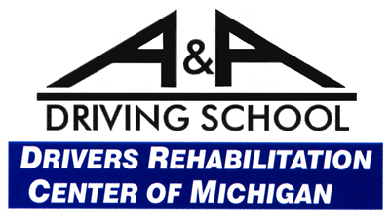

2023 EXHIBITORS

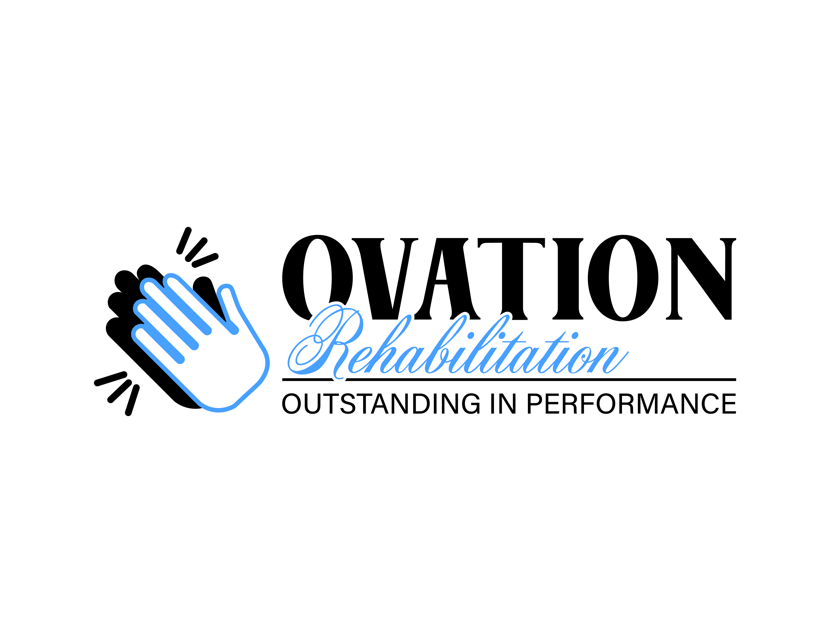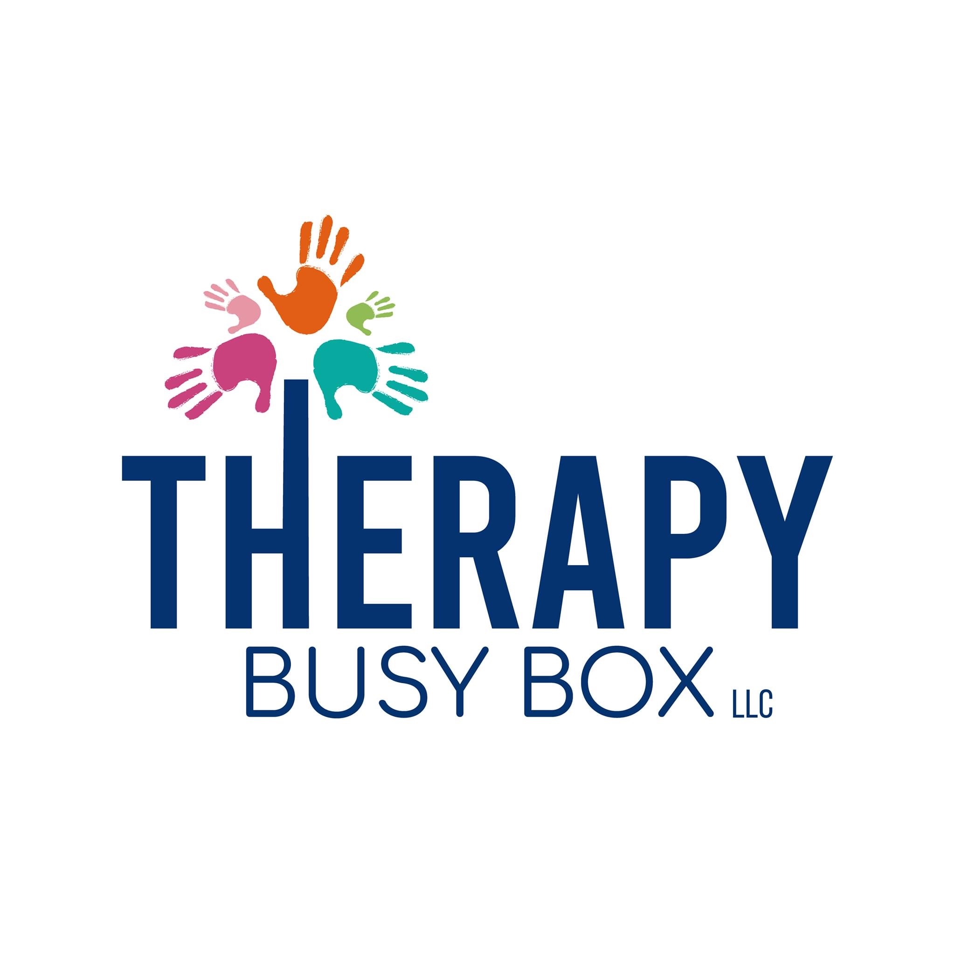

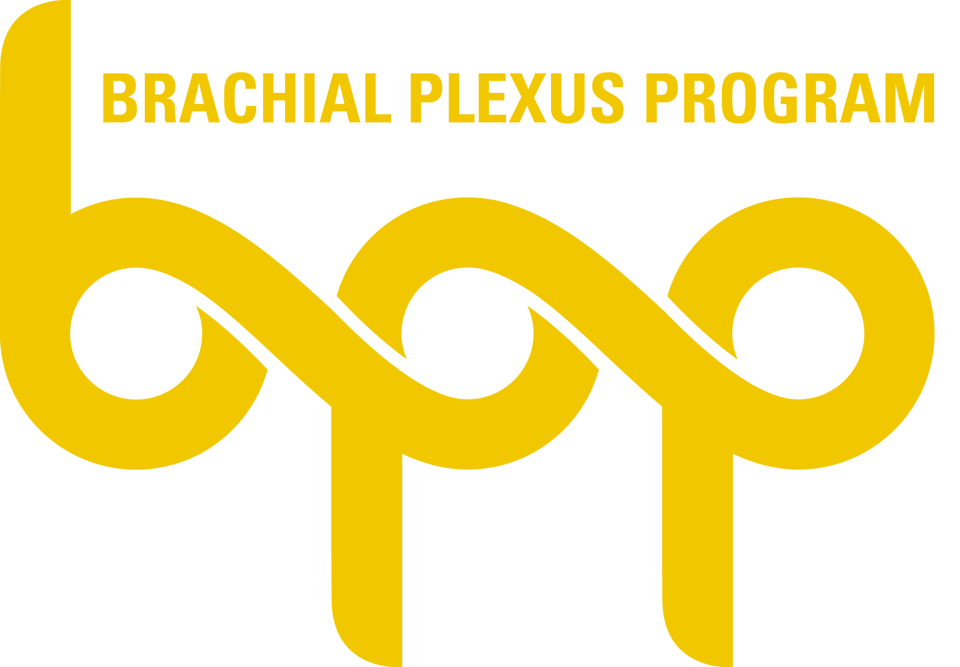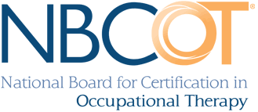
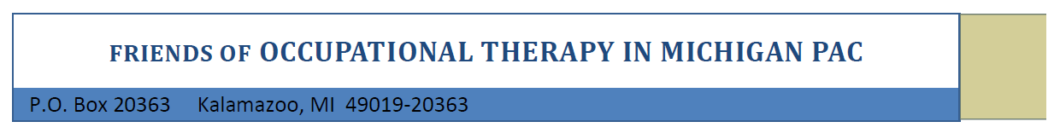

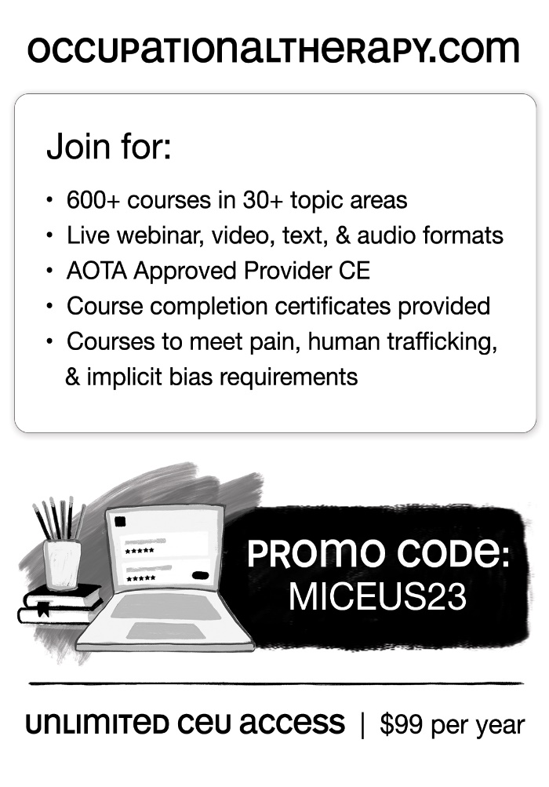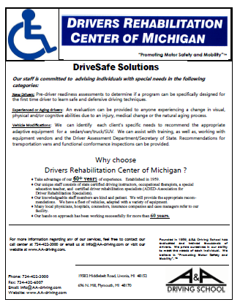

Save the Date
MiOTA Annual Fall Conference
October 18 – 20, 2024
Boyne Mountain Resort

