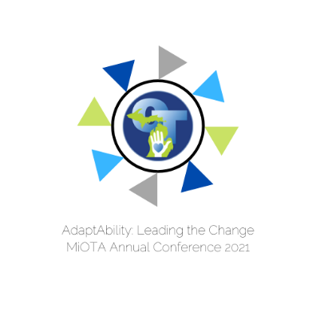

# 2021

# EXHIBITOR SCHEDULE OF EVENTS

# for

# Michigan Occupational Therapy Association

# Annual Fall Conference

# September 30 – October 2, 2021

# Conference Location

**Radisson Plaza Hotel & Suites**

100 W Michigan Ave | Kalamazoo, MI 49007 | Phone: 269-343-3333

**Thursday**

3-7 PM Registration and Set-Up

**Friday**

7-8 AM Registration and Set-Up

8-6:30 Exhibit Hours

8-8:45 Unopposed Exhibiting

8:45-10:15 Sessions

10:15-10:30 Unopposed Exhibiting

10:30-11:30 Sessions

11:30-11:45 Unopposed Exhibiting

11:45-12:45 Lunch

12:24-1 Unopposed Exhibiting

1-3 Sessions

3-4 Unopposed Exhibiting

4-5 Sessions

5-5:15 Unopposed Exhibiting

5:15-6:15 Welcome Reception, Awards Ceremony, Silent Auction

**Saturday**

7-8 AM Registration and Set-Up

8-6:30 Exhibit Hours

8-8:45 Unopposed Exhibiting

8:45-10:15 Sessions

10:15-10:30 Unopposed Exhibiting

10:30-11:30 Sessions

11:30-11:45 Unopposed Exhibiting

11:45-12:45 Lunch

12:24-1 Unopposed Exhibiting

1-3 Exhibitor Break Down