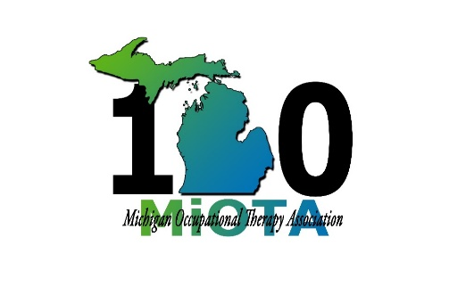
February 1, 2020

Dear Program Director/Academic Fieldwork Coordinator,

The MiOTA Conference Planning Committee is continuing the “Student Ambassador Program” which allows students to volunteer their time to the association through active participating at this year's “Annual Fall Conference." Based on the positive feedback we continue to receive from students who have participated, the committee is pleased to continue the “Student Ambassador” opportunity again this year.

This program is open to all currently enrolled OT/OTA students, whether in class or out on fieldwork. The student will need to complete the “Student Ambassador Application” and return it to MiOTA office by August 15, 2020. Selection of “Student Ambassadors” will be through a blind review of all applications. The student must be a member in good standing (member) of MiOTA at the time they submit their application.

The students will be expected to be available for the entire conference beginning with a short meeting on Thursday September 24th, at 6 PM at the Radisson Hotel in Kalamazoo, MI. Students MUST be available during all scheduled conference events on September 25th and 26th.

The primary responsibility of a Student Ambassador it to:

- Convene assigned sessions (specific job descriptions provided at a meeting on Thursday)
- Assist with running conference
- Be available during conference for additional duties as needed by committee

The complete conference schedule is available at https://www.mi-ota.com. Conference registration will be waived for selected ambassadors. However, if the student chooses to stay at the hotel they student will need to cover that expense on their own. A special student rate at the hotel may be available. The hotel reservation information can be found on the MiOTA website.

It is our hope that by offering the students this opportunity it will encourage them to maintain membership in their professional organization, foster a sense of the importance of professional volunteerism, and develop leadership skills. The MiOTA Conference Planning Committee is committed to actively involving our future leaders (our students) in their professional organization. Please share this exciting opportunity with your students.

Sincerely,

2020 MiOTA Conference Committee

